

CLOUD COMPUTING LAB: 09

Submitted By:
Seerat Fatima
Registration. No:
2023-BSE-060
Submitted To:
Engr. Shoaib
Section:
5B

Task 1 — GitHub CLI, Codespace setup and authentication

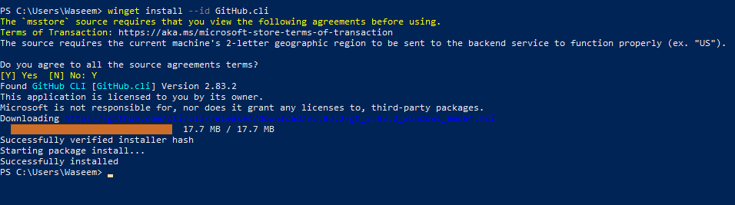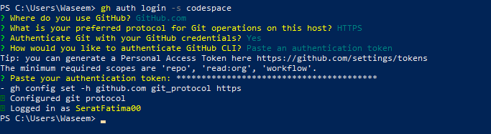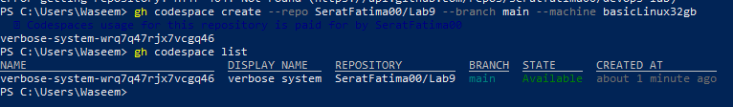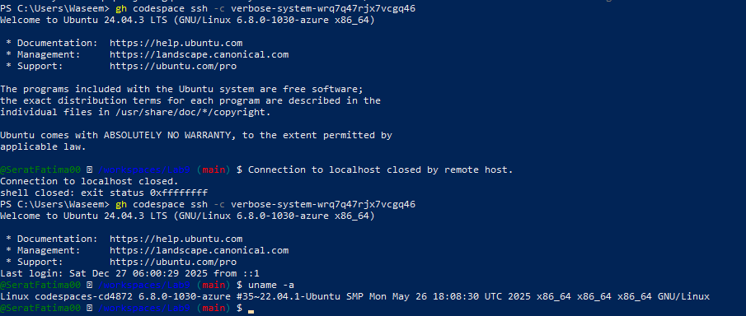

Task 2 — Install AWS CLI inside the Codespace and configure it

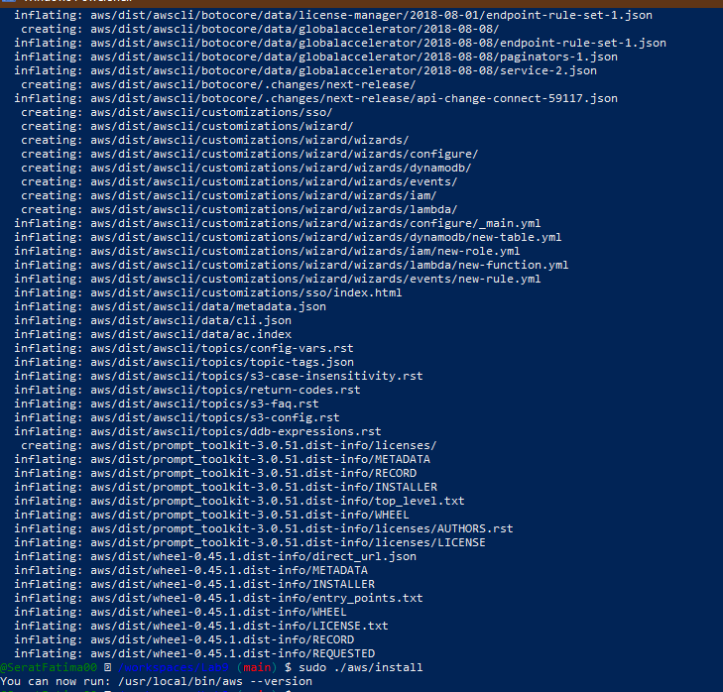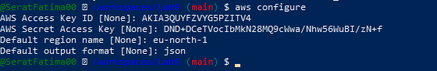
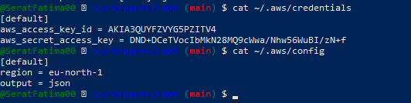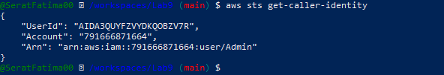

Task 3 — Create security group and add ingress rules using Codespace IP

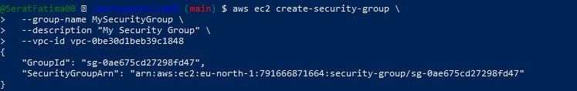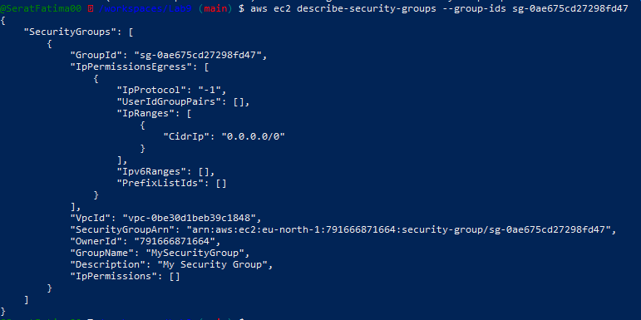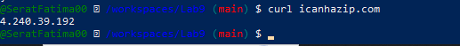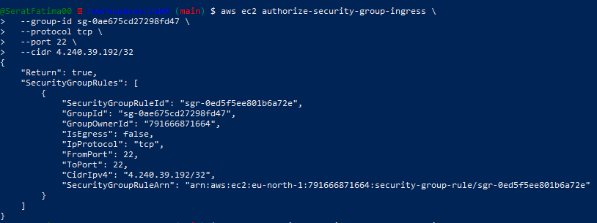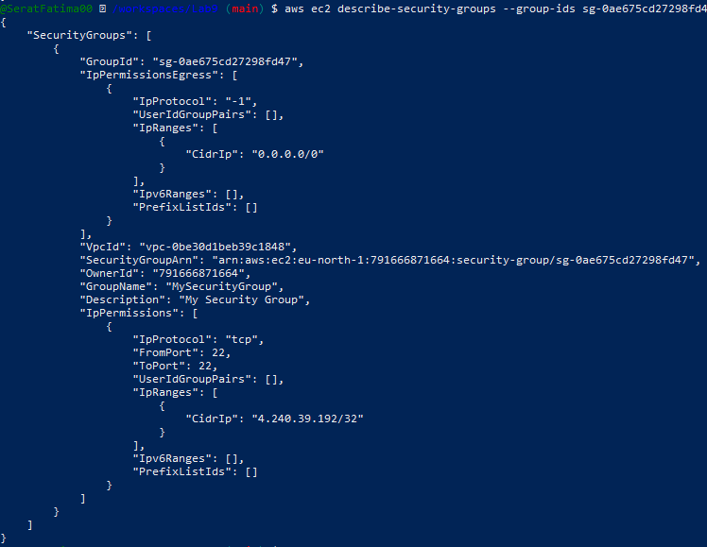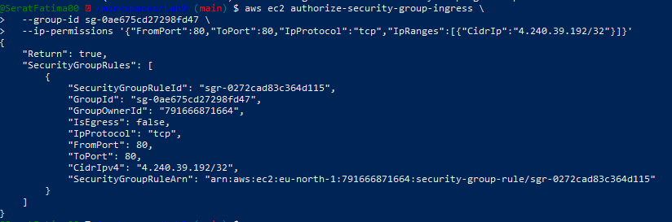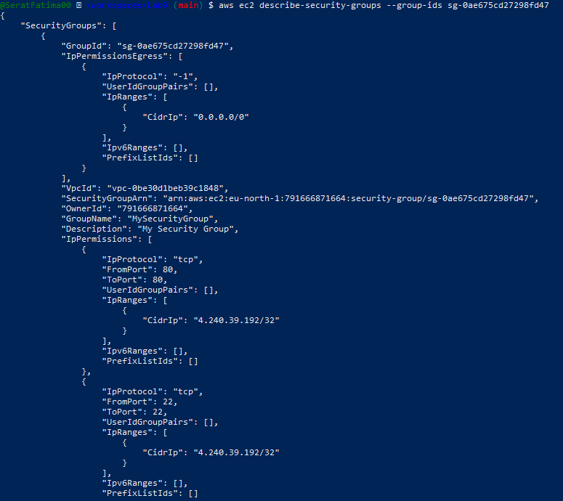

Task 4 — Create a key pair, describe key pairs, and launch EC2 instance

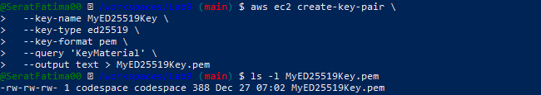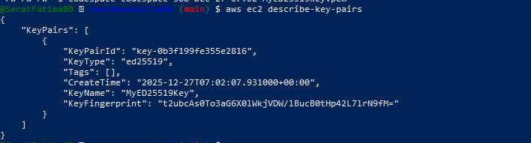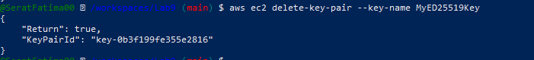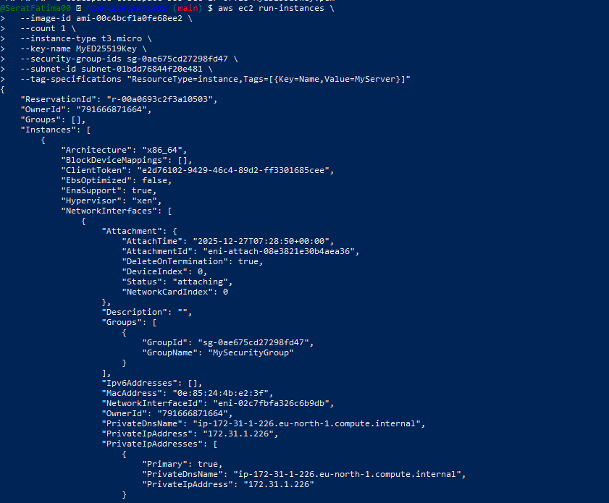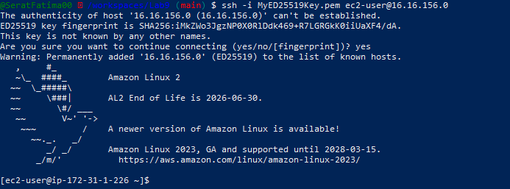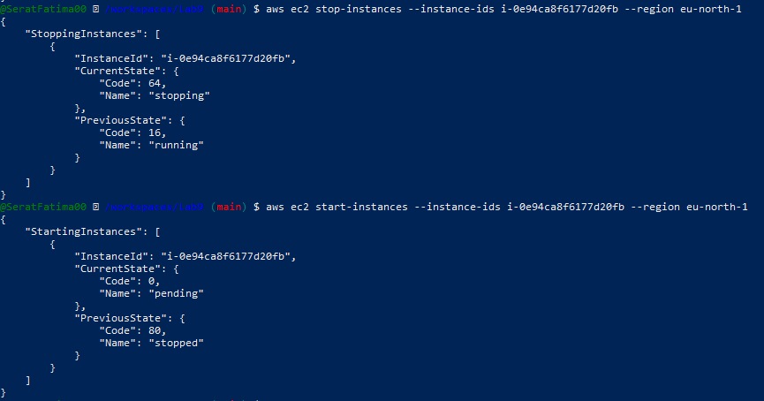

Task 5 — Understand AWS describe-* commands

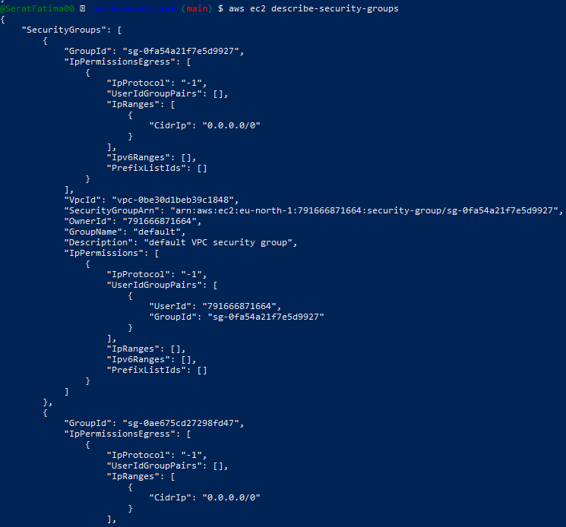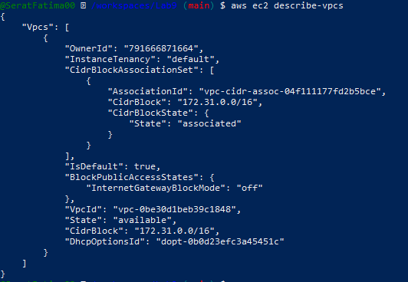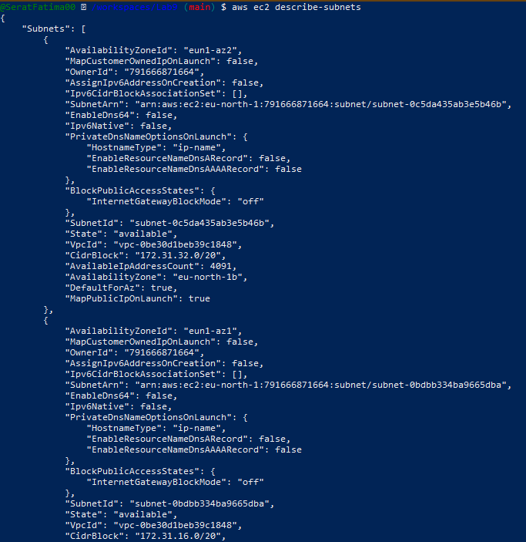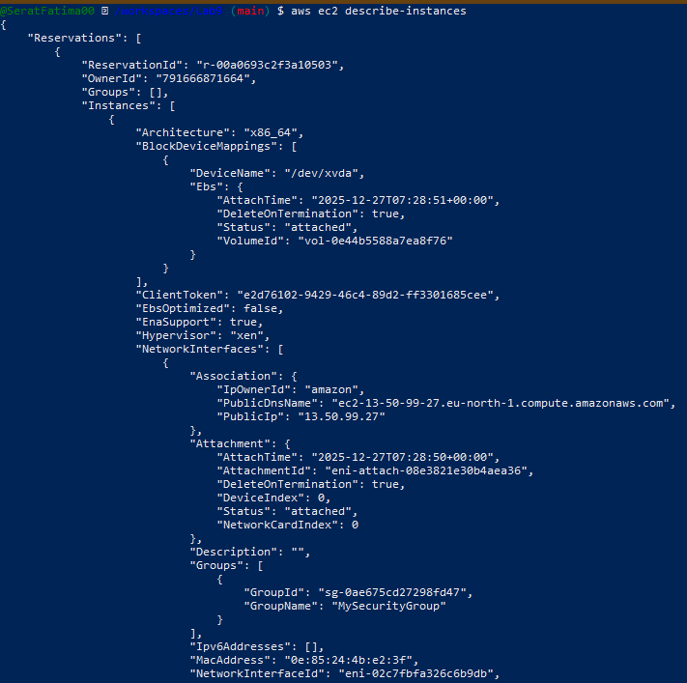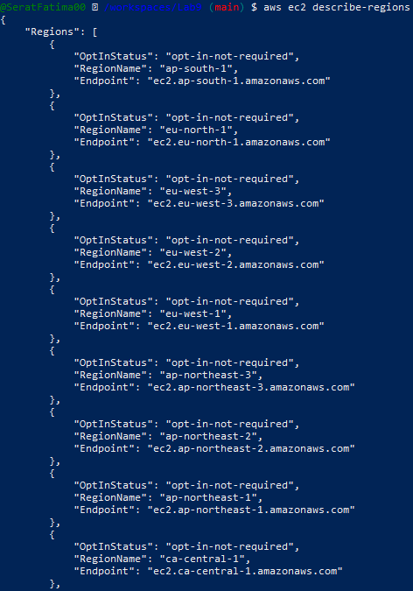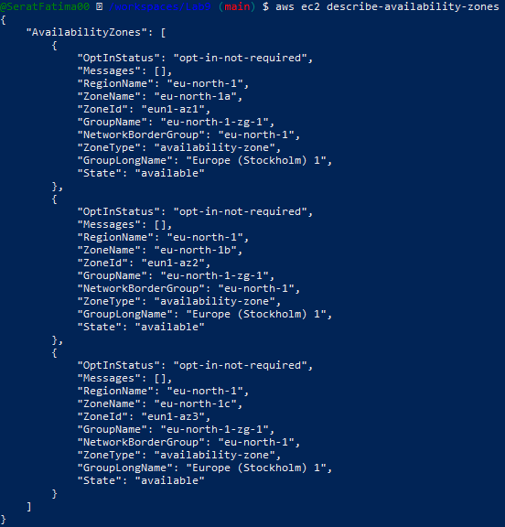

Task 6 — IAM: create group, user, attach policies, create console login & keys

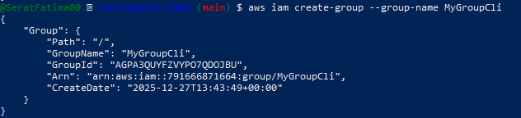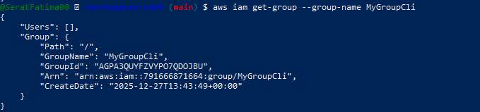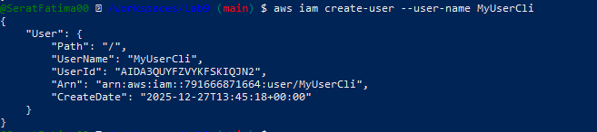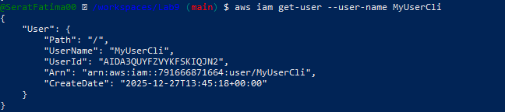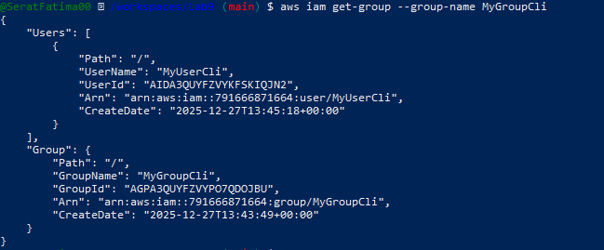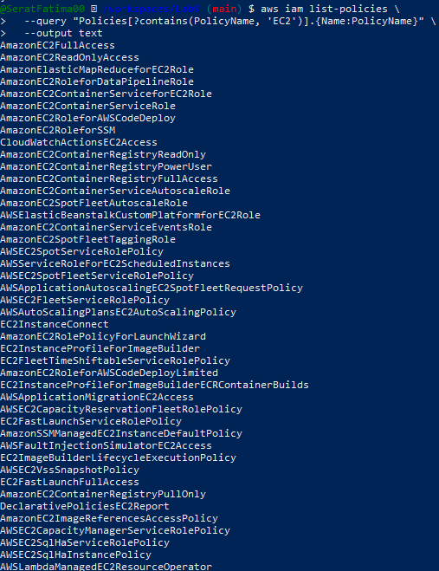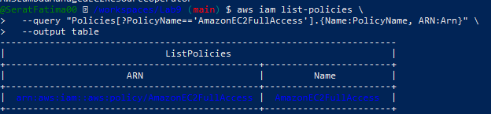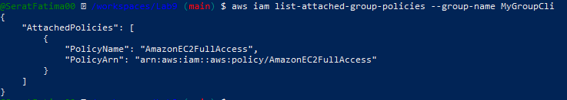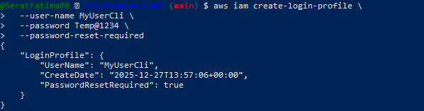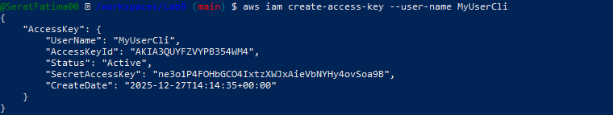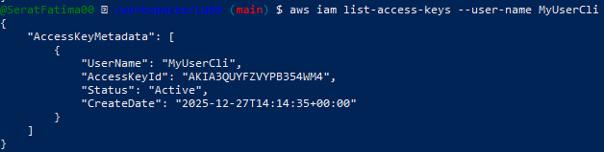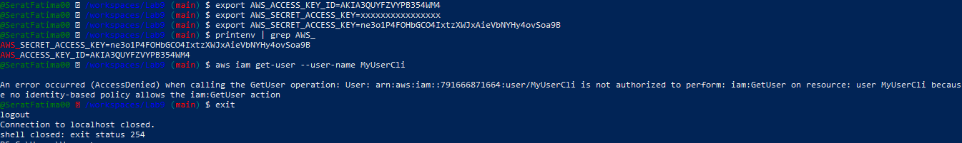

Task 7 — Filters: query with filters to find instances and their attribute
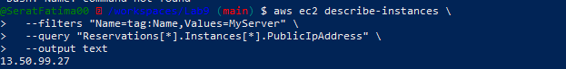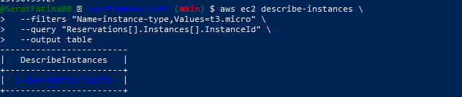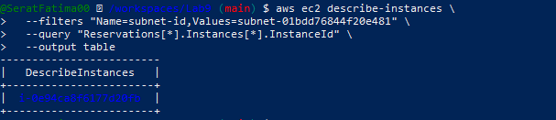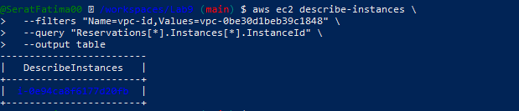

Task 8 — Use --query to format outputs for reporting

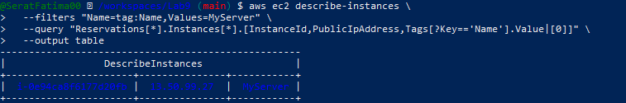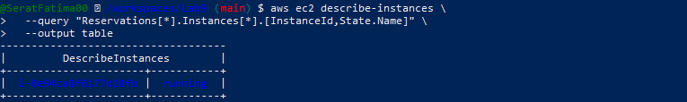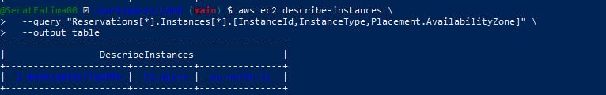

Cleanup — Remove resources to avoid charges

